**Name**: Shradha Mallikarjun Patil

**USN:** 2GI20CS144

**Termwork 4**

* 1. The class Cylinder inherits all the instance variables (radius and color) and methods (getRadius(), getArea(), among others) from its superclass Circle. It further defines a variable called height, three methods getHeight(), setHeight() and getVolume() and its own constructors. Implement the hierarchy as shown below:

Circle

radius:double = 1.0

color:String = “Red”

Circle()

Circle(radius:double)

Circle(radius:double, color:String)

getRadius():double

setRadius(radius:double):void

getColor():String

getColor(color:String):void

getArea():double

Cylinder

height:double = 1.0

Cylinder()

Cylinder(height:double)

Cylinder(height:double, radius:double)

Cylinder(height:double, radius:double,

color:String)

getHeight():double

setHeight(height:double):void

getVolume():double

**Program:**

import java.util.*;

class Circle

{

double radius;

String color;

Circle()

{

radius=1.0;

color="Turquoise";

}

Circle(double radius,String color)

{

this.radius=radius;

this.color=color;

}

double getRadius()

{

return radius;

}

void setRadius(double radius)

{

this.radius=radius;

}

String getColor()

{

return color;

}

void setColor(String color)

{

this.color=color;

}

double getArea()

{

return 3.142*radius*radius;

}

}

class Cylinder extends Circle

{

double height;

Cylinder()

{

super();

height=1.0;

}

Cylinder(double height)

{

super();

this.height=height;

}

Cylinder(double height,double radius,String color)

{

super(radius,color);

this.height=height;

}

double getHeight()

{

return height;

}

void setHeight(double height)

{

this.height=height;

}

double getVolume()

{

return getArea()*height;

}

}

class Main

{

public static void main(String args[])

{

Circle c=new Circle(3.0,"Teal");

System.out.println("Radius of Circle 1="+c.getRadius());

System.out.println("Color of circle 1="+c.getColor());

c.setColor("Sapphire");

System.out.println("Changed color of circle 1="+c.getColor());

System.out.println("Area of circle 1="+c.getArea());

Circle ci=new Circle();

System.out.println("\nRadius of Circle 2="+ci.getRadius());

System.out.println("Color of circle 2="+ci.getColor());

ci.setColor("Sapphire");

System.out.println("Changed color of circle 2="+ci.getColor());

System.out.println("Area of circle 2="+ci.getArea());

Cylinder c1=new Cylinder(2,3,"Mauve");

System.out.println("\nRadius of cylinder 1="+c1.getRadius());

System.out.println("Height of cylinder 1="+c1.getHeight());

System.out.println("Color of cylinder 1="+c1.getColor());

System.out.println("Volume of cylinder 1="+c1.getVolume());

Cylinder c2=new Cylinder();

System.out.println("\nRadius of cylinder 2="+c2.getRadius());

System.out.println("Height of cylinder 2="+c2.getHeight());

System.out.println("Color of cylinder 2="+c2.getColor());

System.out.println("Volume of cylinder 2="+c2.getVolume());

}

}

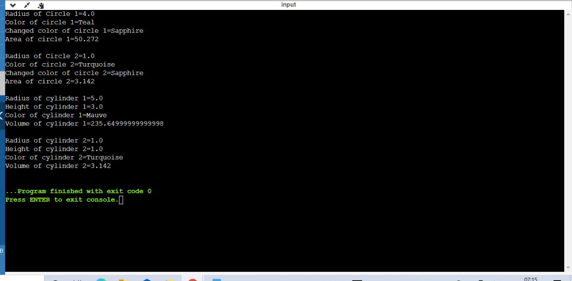

* 1. Implement a BANK class to demonstrate the inheritance in Java by implementing getRateOfInterest() member function for three different banks, as shown below.

Java method overriding example of bank

**Program:**

import java.util.*;

class Bank

{

protected String name;

protected double balance;

protected int accountNumber;

protected float inamt;

Bank( String name,double balance, int accountNumber , float inamt)

{

this.balance=balance;

this.name=name;

this.accountNumber=accountNumber;

this.inamt=inamt;

}

void disp()

{

System.out.println("Account holder:"+name+"\nAccount number:"+accountNumber);

System.out.println("Balance:"+balance);

}

}

interface interest

{

float getRateofInterest(int t);

}

class SBI extends Bank implements interest

{

SBI(String name,double balance, int accountNumber , float r)

{

super(name,balance,accountNumber ,r);

}

public float getRateofInterest(int t)

{

return (float)(inamt/(balance*t)*100);

}

}

class icici extends Bank implements interest

{

icici(String name,double balance, int accountNumber ,float inamt)

{

super(name,balance,accountNumber ,inamt);

}

public float getRateofInterest(int t)

{

return (float)(inamt/(balance*t)*100);

}

}

class Axis extends Bank implements interest

{

Axis(String name,double balance, int accountNumber , float inamt)

{

super(name,balance,accountNumber ,inamt);

}

public float getRateofInterest(int t)

{

return (float)(inamt/(balance*t)*100);

}

}

class Main

{

public static void main(String args[])

{

SBI s=new SBI("Hozier",45100,123,2500);

s.disp();

System.out.println("Rate of interst is "+s.getRateofInterest(3)+"%\n");

Axis a=new Axis("Harry",28000,12,1500);

a.disp();

System.out.println("Rate of interst is "+a.getRateofInterest(2)+"%\n");

icici i=new icici("Louis",29000,24,1800);

i.disp();

System.out.println("Rate of interst is "+i.getRateofInterest(5)+"%\n");

}

}

**Output:**

